**Lab 5: Binary Arithmetic**

1. **Objectives**

* Understand the concept of binary addition and subtraction.
* Learn about half and full binary adders.
* Perform binary addition and subtraction using IC7483.
* Understand the concept of BCD addition and implement a BCD adder using IC7483

1. **Theory**

Digital computers perform a variety of information-processing tasks. Among the functions encountered are the various arithmetic operations. The most basic arithmetic operation is the addition of two binary digits. This simple addition consists of four possible elementary operations: 0 + 0 = 0, 0 + 1 = 1, 1 + 0 = 1, and 1 + 1 = 10. The first three operations produce a sum of one digit, but when both augend and addend bits are equal to 1, the binary sum consists of two digits. The higher significant bit of this result is called a ***carry***. When the augend and addend numbers contain more significant digits, the carry obtained from the addition of two bits is added to the next higher order pair of significant bits. A combinational circuit that performs the addition of two bits is called a ***half adder***. One that performs the addition of three bits (two significant bits and a previous carry) is a ***full adder***. The names of the circuits stem from the fact that two half adders can be employed to implement a full adder.

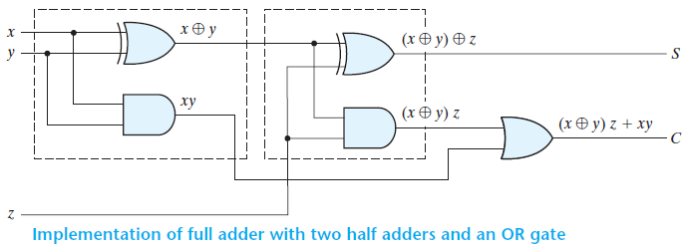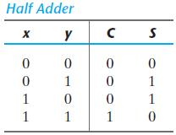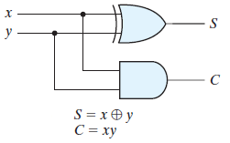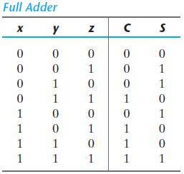

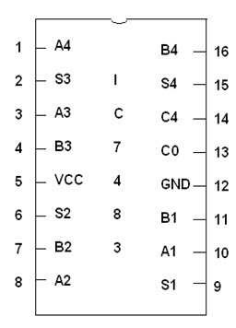10+2

**1010**

**0010**

**____**

**1100**

**10-2=10+(-2)**

**2’s compliment of 2: (-2)**

**0010**

**1101<<1’s compliment**

**+1**

**____**

**1110<<2’s compliment of 2 (-2)**

**1010**

**+1110**

**_____**

**11000**

**New Apparatus:**

**IC 7483:** The 16-pin 7483 IC is a 4-bit full adder. That means, it can take two 4-bit binary numbers (A4A3A2A1 and B4B3B2B1) and calculate the sum (S4S3S2S1). The input carry (if any) is connected to C0 and the output carry is obtained from C4. Unlike most other ICs used so far, in the 7483, the 5V VCC needs to be connected to pin 5 and the ground to pin 12.

Two 7483 ICs can be cascaded to form an 8-bit ripple-through-carry adder. The lower 4 bits of each number is used as input for the first 7483 and the output carry is connected to the input carry of the next 7483. The higher 4 bits of each number is used as input for the second 7483. The first IC provides the lower 4 bits of the sum and the second one provides the upper 4 bits.

**Figure B1:**

Pinout of IC7483

**Experiment 1: Binary Adder-Subtractor**

**C.1 Apparatus**

* Trainer board
* 1 x IC 7483 4-bit binary adder
* 1 x IC 7486 quadruple 2-Input XOR gates

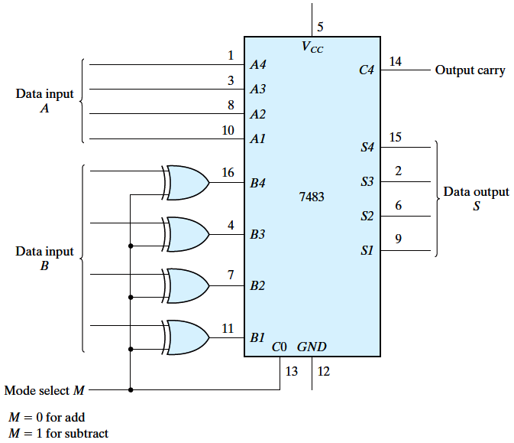

**D.1 Procedure**

**Figure D.1.1** 4-bit adder-subtractor

M B XOR

0 0 0

0 1 1

1 0 1

1 1 0

1. Construct the 4-bit adder-subtractor circuit of **Figure D.1.1**.
2. Complete the operations in **Table F.1.1**.
   1. For each operation, convert the first operand to binary as A, and the second operand as B.
   2. Write down the value of M required for the operation.
   3. Note down the values of the output carry C4 and data output S4-S1. Verify the results.

**E.1 Report**

1. Comment on the use of the XOR gates and the M bit of the 4-bit adder-subtractor.
2. Simulate the 4-bit adder-subtractor circuit in Logisim from the Figure D.1.1. Provide a screenshot of the Logisim circuit schematic with your report.

**Experiment 2: Ripple-Through-Carry Adder**

**C.2 Apparatus**

* Trainer board
* 2 x IC 7483 4-bit binary adder

**D.2 Procedure**

1. Deduce the IC diagram of an 8-bit ripple-through-carry binary adder using two 4-bit adders, clearly showing the pin numbers.
2. Construct the 8-bit adder.
3. Complete the operations in **Table F.2.1**

**E.2 Report**

1. Draw the IC diagram for the 8-bit ripple-through-carry adder.
2. Simulate 8 bit Ripple-through-carry Adder in Logisim. Provide a screenshot of the Logisim circuit schematic with your report.

**Experiment 3: BCD Adder**

**C.3 Apparatus**

* Trainer board
* 2 x IC 7483 4-bit binary adder
* 1 x IC 7408 quadruple 2-Input AND gates
* 1 x IC 7432 quadruple 2-Input OR gates

**D.3 Procedure**

1. Complete **Table F.3.1** for the BCD sum.
2. Construct the circuit of **Figure D.3.1**.
3. 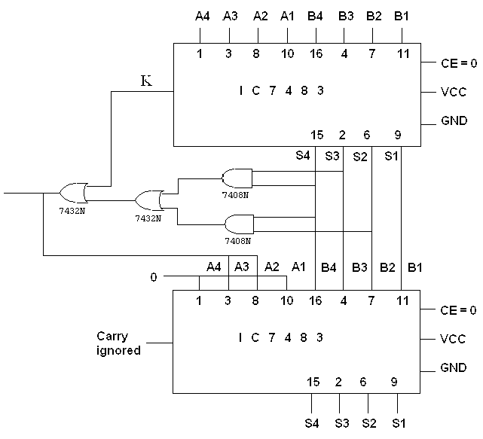Verify the outputs in **Table F.3.2**

**Figure D.3.1**

**E.3 Report**

1. With reference to Figure D.3.1 and Table F.3.1 explain how Binary Sum is converted into BCD Sum.

**F.1 Experimental Data (Binary Adder-Subtractor):**

|  |  |  |  |  |  |
| --- | --- | --- | --- | --- | --- |
| **Operation** | **M** | **A4 A3 A2 A1** | **B4 B3 B2 B1** | **C4** | **S4 S3 S2 S1** |
| 7 + 5 | 0 | 0 1 1 1 | 0 1 0 1 | 0 | 1 1 0 0 |
| 4 + 6 | 0 | 0 1 0 0 | 0 1 1 0 | 0 | 1 0 1 0 |
| 9 + 11 |  |  |  |  |  |
| 15 + 15 | 0 | 1 1 1 1 | 1 1 1 1 | 1 | 1 1 1 0 |
| 7 – 5 | 1 | 0 1 1 1 | 0 1 0 1 | 1 | 0 0 1 0 |
| 4 – 6 | 1 | 0 1 0 0 | 0 1 1 0 | 0 | 1 1 1 0 |
| 11 – 2 |  |  |  |  |  |
| 15 – 15 | 1 | 1 1 1 1 | 1 1 1 1 | 1 | 0 0 0 0 |

**Table F.1.1**

**F.2 Experimental Data (Ripple-Through-Carry Adder):**

|  |  |  |  |  |
| --- | --- | --- | --- | --- |
| **Operation** | **A8 A7 A6 A5 A4 A3 A2 A1** | **B8 B7 B6 B5 B4 B3 B2 B1** | **Overflow Carry** | **S8 S7 S6 S5 S4 S3 S2 S1** |
| 7 + 5 | 0 0 0 0 0 1 1 1 | 0 0 0 0 0 1 0 1 |  |  |
| 18 + 19 |  |  |  |  |
| 72 + 83 | 0 1 0 0 1 0 0 0 | 0 1 0 1 0 0 1 1 | 0 | 1 0 0 1 1 0 1 1 |
| 129 + 255 |  |  |  |  |

**Table F.2.1**

**F.3 Experimental Data (BCD Adder):**

|  |  |  |  |  |  |  |  |  |  |  |
| --- | --- | --- | --- | --- | --- | --- | --- | --- | --- | --- |
| Decimal Value | Binary Sum | | | | | BCD Sum | | | | |
| K | S4 | S3 | S2 | S1 | C | S4 | S3 | S2 | S1 |
| 0 | 0 | 0 | 0 | 0 | 0 | 0 | 0 | 0 | 0 | 0 |
| 1 | 0 | 0 | 0 | 0 | 1 | 0 | 0 | 0 | 0 | 1 |
| 2 | 0 | 0 | 0 | 1 | 0 | 0 | 0 | 0 | 1 | 0 |
| 3 | 0 | 0 | 0 | 1 | 1 | 0 | 0 | 0 | 1 | 1 |
| 4 | 0 | 0 | 1 | 0 | 0 | 0 | 0 | 1 | 0 | 0 |
| 5 | 0 | 0 | 1 | 0 | 1 | 0 | 0 | 1 | 0 | 1 |
| 6 | 0 | 0 | 1 | 1 | 0 | 0 | 0 | 1 | 1 | 0 |
| 7 | 0 | 0 | 1 | 1 | 1 | 0 | 0 | 1 | 1 | 1 |
| 8 | 0 | 1 | 0 | 0 | 0 | 0 | 1 | 0 | 0 | 0 |
| 9 | 0 | 1 | 0 | 0 | 1 | 0 | 1 | 0 | 0 | 1 |
| 10 | 0 | 1 | 0 | 1 | 0 | 1 | 0 | 0 | 0 | 0 |
| 11 | 0 | 1 | 0 | 1 | 1 | 1 | 0 | 0 | 0 | 1 |
| 12 | 0 | 1 | 1 | 0 | 0 | 1 | 0 | 0 | 1 | 0 |
| 13 | 0 | 1 | 1 | 0 | 1 | 1 | 0 | 0 | 1 | 1 |
| 14 | 0 | 1 | 1 | 1 | 0 | 1 | 0 | 1 | 0 | 0 |
| 15 | 0 | 1 | 1 | 1 | 1 | 1 | 0 | 1 | 0 | 1 |
| 16 | 1 | 0 | 0 | 0 | 0 | 1 | 0 | 1 | 1 | 0 |
| 17 | 1 | 0 | 0 | 0 | 1 | 1 | 0 | 1 | 1 | 1 |
| 18 | 1 | 0 | 0 | 1 | 0 | 1 | 1 | 0 | 0 | 0 |
| 19 | 1 | 0 | 0 | 1 | 1 | 1 | 1 | 0 | 0 | 1 |

**Table F.3.1**

|  |  |  |  |  |
| --- | --- | --- | --- | --- |
| **Operation** | **A4 A3 A2 A1** | **B4 B3 B2 B1** | **Overflow Carry** | **S4 S3 S2 S1** |
| 9 + 0 | 1 0 0 1 | 0 0 0 0 | 0 | 1 0 0 1 |
| 9 + 1 | 1 0 0 1 | 0 0 0 1 | 1 | 0 0 0 0 |
| 9 + 2 | 1 0 0 1 | 0 0 1 0 | 1 | 0 0 0 1 |
| 9 + 3 | 1 0 0 1 | 0 0 1 1 | 1 | 0 0 1 0 |
| 9 + 4 | 1 0 0 1 | 0 1 0 0 | 1 | 0 0 1 1 |
| 9 + 5 | 1 0 0 1 | 0 1 0 1 | 1 | 0 1 0 0 |
| 9 + 6 | 1 0 0 1 | 0 1 1 0 | 1 | 0 1 0 1 |
| 9 + 7 | 1 0 0 1 | 0 1 1 1 | 1 | 0 1 1 0 |
| 9 + 8 | 1 0 0 1 | 1 0 0 0 | 1 | 0 1 1 1 |
| 9 + 9 | 1 0 0 1 | 1 0 0 1 | 1 | 1 0 0 0 |

**Table F.3.2**

**Decimal >> Binary >> BCD**

**0 >> 0000 >> 0000**

**9 >> 1001 >> 1001**

**10 >> 1010 >> 00010000**

**12 >> 1100 >> 00010010**

**34 >> Binary >> 00110100**